Alrich Rigonios
CSD-310 Module 4 Assignment
MySQL Installation

Show database Output:
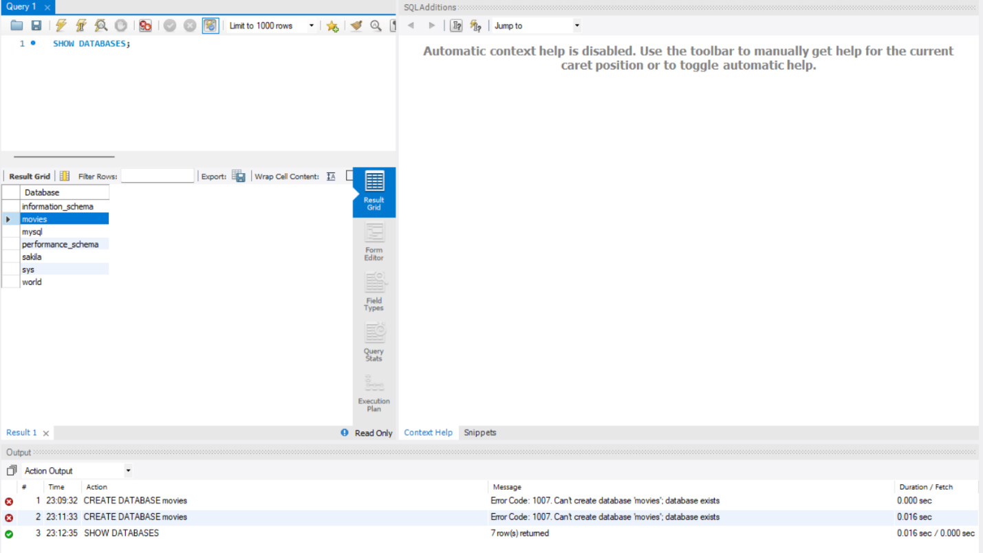
Function 1: COUNT

SQL Statement:
SELECT COUNT (*) AS Total Users FROM MySQL. User.

Explanation:The COUNT function counts the total number of records in a table. In this case, it counts how many users exist in the MySQL. User table.
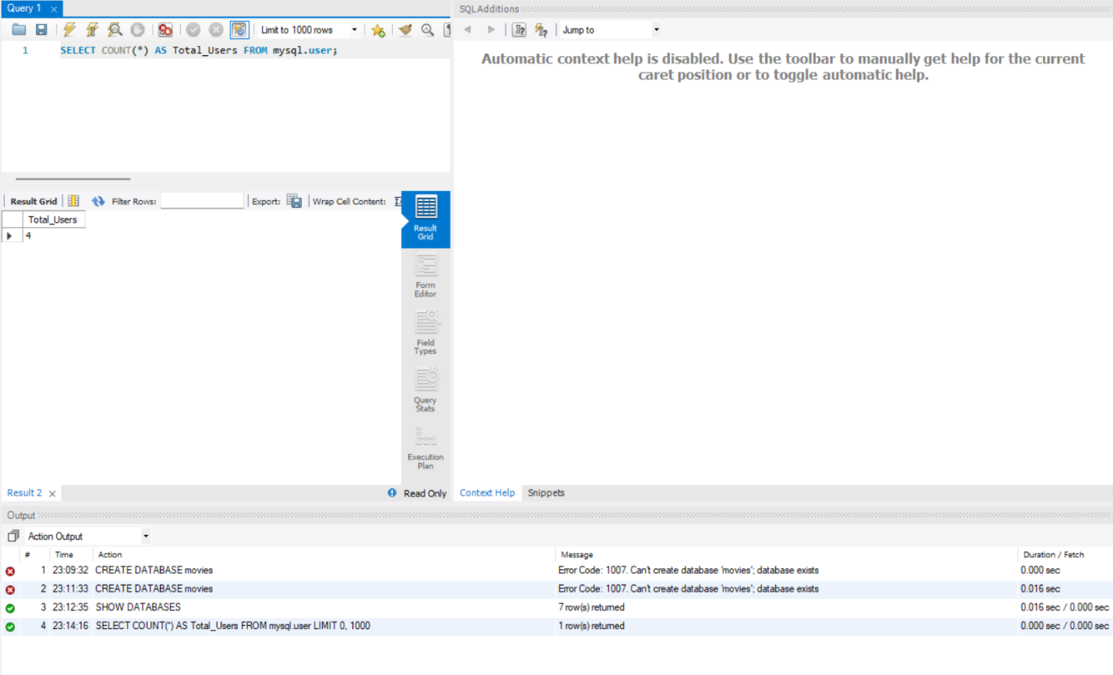
Function 2: UPPER

SQL Statement:
SELECT UPPER(User) AS Uppercase User FROM MySQL. User;

Explanation:The UPPER function converts text into uppercase letters. In this query, it converts all usernames to uppercase format.
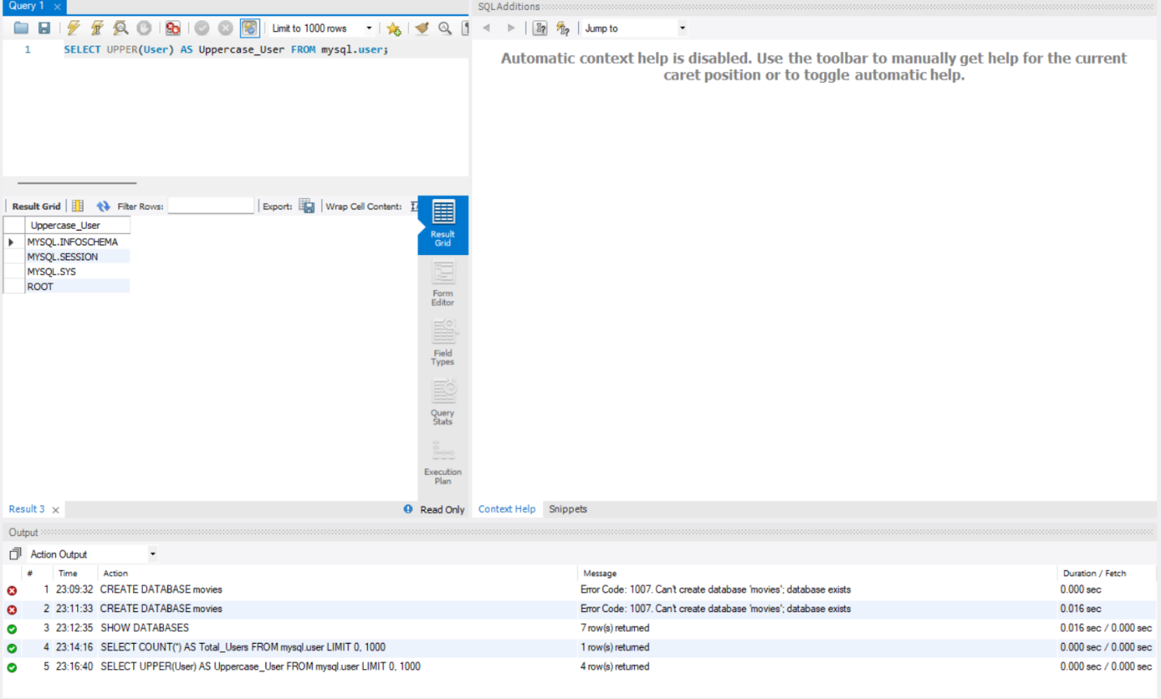
Function 3: LENGTH

SQL Statement:
SELECT LENGTH(User) AS Name Length FROM MySQL. User.

Explanation:The LENGTH function returns the number of characters in a string. In this case, it shows the length of each username.